**Stage 7 – Se7en**

**DESIGNER:** Ike Starnes

|  |
| --- |
| **SCORING:** Comstock 28 rounds.  **TARGETS:** 11 cardboard targets and 6 steel targets  **SCORED HITS:** 2 Best hits per carboard will be scored. Steel must fall to score. |

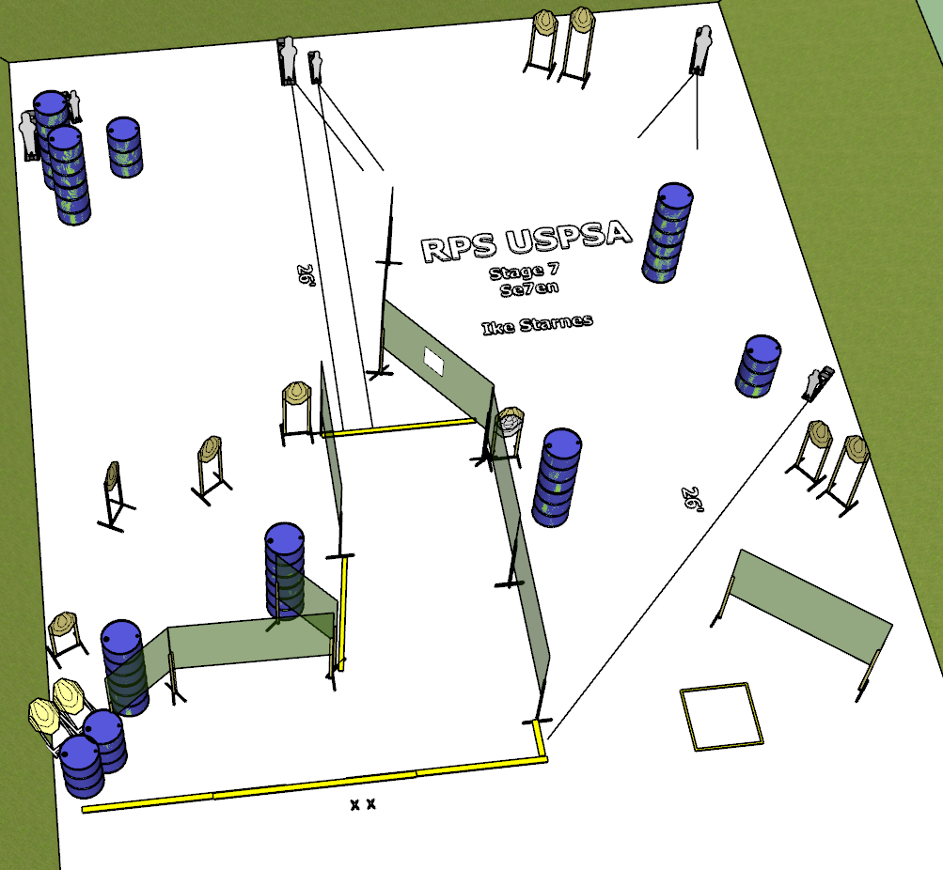

**Written Stage Briefing:**

**Stage 7 – Se7en -** is a 28 round, 140 point, comstock course. There are 11 cardboard targets and 6 steel targets. The best 2 hits per cardboard target will be scored. The steel must fall to score.

**Start position** Anywhere.

**Handgun: Loaded and holstered with wrists below belt.**

**PCC: Loaded held in both hands, stock touching belt.**

On the audible start signal, engage targets from within the shooting area.

**USPSA / NROI Range Commands:**

* Make Ready
* Are you ready?
* Standby
* If finished, unload and show clear.
* If clear, hammer down and holster
* Range is clear

**Setup Notes:**

8 Single Wall Stands

5 Double Wall Stands

5 Full Walls

1 Port Walls

1 Half Wall

9 Target stands / 18 target sticks

2 45 target stands / 4 short sticks

6 Popper bases

2 Poppers

4 Mini Poppers

1 Starting Xs

1 Shooting Box

16+ barrels